

**PRAKTIKUM BASIS DATA**

INF1133

**LAPORAN PRAKTIKUM 10**

Oleh :

*Akhmad Qasim*

*2211102441237*

Teknik Informatika

Fakultas Sains & Teknologi

Universitas Muhammadiyah Kalimantan Timur

Samarinda, 2023

**Laporan Praktikum 10:**

**Percobaan & Latihan:**

1. create database dbtoko;  
   
2. show databases;  
   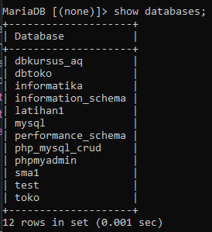
3. use dbtoko;  
   
4. create table tblkelompok(

idkelompok int not null auto_increment primary key,

kelompok varchar(100)

);

1. show tables;  
   A picture containing text, font, screenshot, number

   Description automatically generated
2. desc tblkelompok;  
   A picture containing screenshot, text, font, line

   Description automatically generated
3. create table tblbarang(

idbarang int not null auto_increment primary key,

idkelompok int,

barang varchar(200),

stok float,

hargabeli float

);

1. show tables;  
   A picture containing text, font, screenshot, number

   Description automatically generated
2. alter table tblbarang add harga_jual float;  
   A picture containing text, screenshot, font, line

   Description automatically generated
3. desc tblbarang;  
   A screen shot of a computer program

   Description automatically generated with low confidence
4. alter table tblbarang modify stok int;  
   A picture containing text, font, screenshot, line

   Description automatically generated
5. desc table tblbarang;  
   A screen shot of a computer

   Description automatically generated with medium confidence
6. alter table tblbarang alter column stok set default 0;  
   A black background with white text

   Description automatically generated with low confidence
7. desc tblbarang;  
   A screen shot of a computer

   Description automatically generated with medium confidence
8. alter table tblbarang add stokminimal int;  
   A black background with white text

   Description automatically generated with low confidence
9. desc tblbarang;  
   A picture containing text, screenshot, number

   Description automatically generated
10. alter table tblbarang drop column stokminimal;  
    A picture containing text, screenshot, font, line

    Description automatically generated
11. desc tblbarang;  
    A screen shot of a computer program

    Description automatically generated with low confidence
12. alter table tblbarang change stok stok_barang int;  
    A black background with white text

    Description automatically generated with low confidence
13. desc tblbarang;  
    A screen shot of a computer program

    Description automatically generated with low confidence
14. create table table_pelanggan(

id_pelanggan int,

nama varchar(200),

alamat varchar(255)

);

1. alter table table_pelanggan modify id_pelanggan int not null auto_increment primary key;  
   
2. desc table_pelanggan;  
   A picture containing screenshot, text, font

   Description automatically generated
3. show create table table_pelanggan;  
   A screen shot of a computer program

   Description automatically generated with low confidence
4. create table table_order(

id_order int not null auto_increment primary key,

id_pelanggan int,

tanggal_order date,

total float,

bayar float,

kembali float

);

1. desc table_order;  
   A screen shot of a computer

   Description automatically generated with medium confidence
2. alter table table_order add faktur varchar(50) after id_pelanggan;  
   A black screen with white text

   Description automatically generated with low confidence
3. desc table_order;  
   A screen shot of a computer

   Description automatically generated with low confidence
4. create table order_detail(

id_order_detail int not null auto_increment primary key,

id_order int,

id_barang int,

jumlah int,

harga_jual float

);  
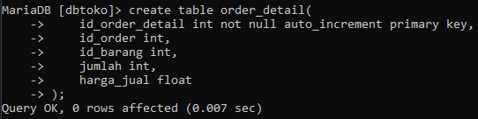

1. desc order_detail;  
   A picture containing text, screenshot, software

   Description automatically generated
2. create index pelanggan_index on table_pelanggan (nama);  
   A screen shot of a computer code

   Description automatically generated with low confidence
3. create index barang_index on tblbarang (barang);  
   A picture containing text, screenshot, font, line

   Description automatically generated
4. show index from tblbarang;  
   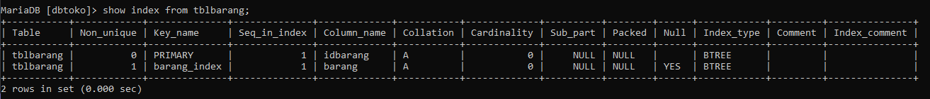
5. drop index pelanggan_index on table_pelanggan;  
   A black background with white text

   Description automatically generated with low confidence